Title Page

Theme Tussle

Take action in this theatre-based fighting game!

Jake Soucy

2024-03-07

Jakennik01@gmail.com

**Document Revision History:**

|  |  |  |  |
| --- | --- | --- | --- |
| Version | Date | Author(s) | Changes |
| 0.2 | March 6, 2024 | Jake Soucy | Changed Title Page, 2 Sections and updated TOC. |
| 0.3 | March 7, 2024 | Jake Soucy |  |
|  |  |  |  |

Table of Contents

1. Section I - Game Overview 5

1.1. Game Concept 5

1.2. Design History 5

1.3. Genre 5

1.4. Target Audience 5

1.5. Game Flow Summary 5

1.6. Look and Feel 5

1.7. Project Scope 5

1.7.1. Number of locations 5

1.7.2. Number of levels 5

1.7.3. Number of NPC’s 5

1.7.4. Number of playable characters 5

2. Section II - Gameplay and Mechanics 6

2.1. Gameplay 6

2.1.1. Game Progression 6

2.1.2. Mission/challenge Structure 6

2.1.3. Objectives – What are the objectives of the game? 6

2.1.4. Play Flow – How does the game flow for the game player? 6

2.2. Mechanics 6

2.2.1. Physics 6

2.2.2. Movement 6

2.2.3. Objects 6

2.2.4. Combat 6

2.3. Screen Flow 7

2.3.1. Screen Flow Chart 7

2.3.2. Screen Descriptions 7

2.4. Game Options 7

3. Section III – Story, Setting and Character 7

3.1. Story and Narrative 7

3.1.1. Back story 7

3.1.2. Plot Elements 7

3.1.3. Game Progression 7

3.1.4. Cut Scenes 8

3.2. Game World 8

3.2.1. General look and feel of world. 8

3.2.2. Area #1 8

3.2.3. Area #2 8

3.2.4. Area #3 9

3.3. Characters 9

3.3.1. Character #1 9

3.3.2. Character #2 9

3.3.3. Character #3 10

3.3.4. Character #4 10

4. Section V - Interface 11

4.1. Visual System 11

4.1.1. HUD - What controls 11

4.1.2. Menus 11

4.1.3. Rendering System 11

4.1.4. Camera 11

4.1.5. Lighting Models 11

4.2. Control System 11

4.3. Audio 11

4.4. Music 11

4.5. Sound Effects 11

4.6. Help System 11

5. Section VI - Artificial Intelligence 11

5.1. Opponent AI 11

5.2. Support AI 12

5.2.1. Player and Collision Detection 12

5.2.2. Pathfinding 12

6. Section VII – Technical 12

6.1. Target Hardware and operating system 12

6.2. Supported game controllers and peripherals 12

7. Section VIII – Game Art 12

7.1. Concept Art 12

7.2. Style Guides 12

7.3. Characters 12

7.4. Environments 12

7.5. Equipment 12

7.6. Cut scenes 12

7.7. Miscellaneous 12

# Section I - Game Overview

## Game Concept

In this 2D fighting game, the user controls one of four characters they’ve selected to combat against another player or a computer. The goal is to have the opposing character’s health points reach zero by utilizing an array of moves against them. The game is fast-paced and for true fighting game fans.

## Design History

This is a living document and will change as you develop your game. This section maintains a history of any significant changes to your game.

## Genre

Theme Tussle is a fighting game with an arcade feel to it.

## Target Audience

Fighting game enthusiasts are the primary target audience, and we help newer players who still want to give the game a shot.

## Game Flow Summary

The user can use the ASDW keys to move in these directions: W makes you jump, holding S makes you crouch, A makes you walk to the left, and D makes you walk to the right. A customizable button selection is planned as well. Going backward will be slower than moving forward, and gravity in the game is also included.

## Look and Feel

The style attempted to be delivered is paper people in colourful worlds. The characters look full of personality that represents their theme.

## Project Scope

A summary of the scope of the game.

### Number of locations

Currently, there are three locations.

### Number of levels

The arcade mode is planned to have four levels.

### Number of NPC’s

There is only one depending on the game mode, as this is a fighting game.

### Number of playable characters

Four characters are planned for this game.

# Section II - Gameplay and Mechanics

## Gameplay

### Game Progression

As for the Versus mode, where you fight against another player, the progression depends on the level of skill both players have. In arcade mode, the more levels you go to, the more likely the enemy computer will attack and perform combos.

### Mission/challenge Structure

The mission is to have your opponent run out of health so you can win. The challenge is avoiding that same fate happening to you.

### Objectives – What are the objectives of the game?

As a fighting game, the objective is to get better at the game and learn how to best your opponent, whether it be through combos, defense, or simple tricks. The challenge is dealing with another player who can beat you in return. This makes the game very competitive and fun.

### Play Flow – How does the game flow for the game player?

The game should feel fast-paced and fun.

## Mechanics

### Physics

Players move on a surface with velocities dependent on their character speed. Gravity is a component in this game which allows a player to jump and fall while attacking. In this game, the player interacts with an enemy in the following manner: If a player’s push box meets the enemy push box, if a player’s hitbox meets an enemy’s hurt box, or if a player’s hitbox meets an enemy’s hitbox. We will go into more detail in their designated section.

### Movement

A player can go left, right, and up with the keys previously mentioned. This changes their velocity, and when the key is released, they stop moving in that direction. If a player jumps, they fall back due to gravity and cannot jump a second time in the air.

### Objects

A character in the game can throw a random assortment of interactable objects. These objects include a rake that, when stepped on, hits and stuns the player for a bit, a bar of soap, which, when stepped on, shoots the player in the opposite direction and finally, a ball of yarn, which, when the user picks up, they can launch a powerful attack. The opposing player must take it away from them before they can catch it.

### Combat

A character has an array of moves they can choose from that change depending on the movement key the player is holding. When a character’s hitbox collides with an enemy hurt box, this will deal damage corresponding to the move’s damage value. When a player gets close to another, push boxes collide, and they can push the other player. Every move has its hit box and hurt box.

## Screen Flow

### Screen Flow Chart

The player starts at the main screen; from there, they can choose to exit, go to options, or go to one of the three modes: Arcade, Versus and Tutorial. When picking one of the modes, the player is sent to the Character Select Screen, and after a character is selected, the player is sent to the game. There are four screens in total: the Main Menu, Settings Menu, Character Select Menu, and the Fight Scene

### Screen Descriptions

#### Main Menu Screen

Holds access to all other screens. This is used to go to all different screens.

#### Settings Screen

This Menu is used to adjust the volume of the in-game songs and change the player's controls.

#### Character Screen

This menu allows the player to choose their character. When in Versus Mode, a second player can join, and the stage can be selected.

## Game Options

You can adjust the volume and change your button settings to have custom controls.

# Section III – Story, Setting and Character

## Story and Narrative

### Back story

There are four characters in this game. A cowgirl named Nina, the king of spiders named Leo, a rogue named Suzie and a jester named Charlie. Their stories will be brushed upon in the future.

### Plot Elements

All four characters have different stories that will be shown in Arcade Mode.

### Game Progression

W.I.P. since the story hasn’t been focused on for the game yet.

### Cut Scenes

#### Cut scene #1

##### Actors

W.I.P. since the story hasn’t been focused on for the game yet.

##### Description

W.I.P. since the story hasn’t been focused on for the game yet.

##### Storyboard

W.I.P. since the story hasn’t been focused on for the game yet.

##### Script

W.I.P. since the story hasn’t been focused on for the game yet.

#### Cut scene #2

W.I.P. since the story hasn’t been focused on for the game yet.

## Game World

### General look and feel of world.

The world in this game changes drastically as it revolves around the characters’ themes. This means that while one area may be a western location, another will be a kingdom where many battles previously occurred.

### Area #1

#### General Description

A western town where cowboys reside. A saloon and a well can be seen in the distance.

#### Character that uses area

Nina is the character who resides here.

### Area #2

#### General Description

A kingdom ruled by the king of spiders.

#### Character that uses area

Leo, the king of spiders.

### Area #3

#### General Description

A distorted dimension where objects can be seen flying everywhere.

#### Character that uses area

Charlie the Jester.

## Characters

### Character #1

Nina

#### Back story

Nina is a cowgirl bounty hunter looking for her next target in pursuit of money.

#### Personality

She is extremely cocky and not hesitant to speak her mind.

#### Look

They wear a cowboy hat along with a plaid shirt and jeans with a gun in their pocket, ready to be drawn. She can be seen holding a clover in her mouth; it’s her good luck charm.

#### The character’s in-game story

Nina’s journey in Arcade Mode is to find and catch the mischievous thief Suzie, as she’s a bounty.

#### Relationship to other characters

Nina views Suzie as a bounty to catch and nothing else. They believe the king to be stuck up and the jester to be creepy.

### Character #2

Suzie

#### Back story

Suzie is a rogue thief who grew up in a poor neighborhood.

#### Personality

A sneaky girl who will try her best not to be seen as she’s a criminal.

#### Look

With how little you can see them, Suzie looks almost like a ninja.

#### The character’s in-game story

Suzie’s story is about finding shelter while avoiding contact with other characters.

#### Relationship to other characters

Suzie finds Nina annoying. They would like to steal from the king and find the jester funny.

### Character #3

Leo

#### Back story

Leo is the king of spiders; they own a kingdom full of loyal minions.

#### Personality

A king who believes in their justice to be true and will not budge to anyone he sees as lesser.

#### Look

They are huge in size and scary in presence.

#### The character’s in-game story

This character simply wants people to step away from his kingdom so he can proceed with his plans.

#### Relationship to other characters

The king of spiders likes only his minions.

### Character #4

Charlie

#### Back story

A jester with a highly odd look on the world. She wants the world to be fun for them, no matter the cost.

#### Personality

They’re crazy.

#### Look

They’re small with a jester’s outfit. No one knows what’s behind the mask.

#### The character’s in-game story

Doing what she likes for cheap thrills.

#### Relationship to other characters

She doesn’t view anyone as people.

# Section V - Interface

## Control System

The controls are WASD for moving and TYU for attacks (Before button settings).

## Music

Every stage is planned to have a theme.

## Sound Effects

Characters will have walking sound effects and attack sound effects.

# Section VI - Artificial Intelligence

## Opponent AI

The AI is planned to toss out moves randomly, and on more complex difficulties, the condition to throw out a move is more likely.

# Section VII – Technical

## Supported game controllers and peripherals

This is planned to be controlled with keyboards and DualShock 4 controllers.

# Section VIII – Game Art

## Concept Art

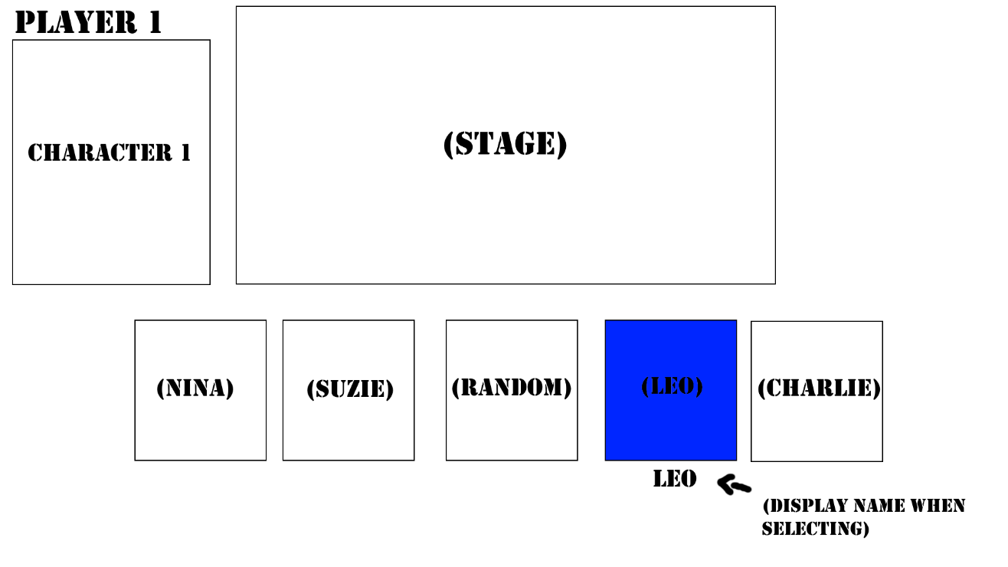

Menu screen for Arcade and Tutorial

## Characters

## Environments

